Chemistry 20

Lesson 11 – Electronegativity, Polarity and Shapes

In our previous work we learned why atoms form covalent bonds and how to draw the resulting organization of atoms. In this lesson we will learn (a) how the combination of bonded electrons and lone pairs of electrons result in different molecular shapes and (b) how unequal sharing of electrons within bonds along with the shape of a molecule result in polar and nonpolar molecules.

# Stereochemistry

All molecules have a definite three-dimensional shape and the study of the shape of chemical compounds is called **stereochemistry**. To help us predict and understand the shapes of molecules we use **Valence-Shell-Electron-Pair-Repulsion** Theory (VSEPR Theory) which was developed by Ronald Nyhlom and Ron Gillespie in 1957. The name implies something very ugly and complicated, but the theory is actually quite simple to understand and use. First of all, since electrons all have the same charge, they repel each other. The VSEPR Theory proposes that valence electron pairs, both shared (bonding) and lone pairs, arrange themselves around the central atom in a molecule in such a way as to **minimize repulsion** between electron pairs Thus, the **bonding and lone pairs of electrons** take-up positions around the central atom **as far away from one another as possible**. (For an alternate explanation of stereochemistry refer to Nelson Chemistry pages 91 to 103.)

VSEPR theory results in **five basic shapes** that we will deal with: tetrahedral, pyramidal, angular, trigonal planar, and linear. (Again, there are more shapes that occur in nature, but we will limit our discussion to the five shapes that arise from molecules that form based on the octet rule.)

## tetrhedralTetrahedral

For molecules like CH4 or SiH4 or CX4 or SiX4 (X represents a halogen) there are **four bonding pairs** and **zero lone pairs** around a central atom. The repulsion between the four bonded pairs results is a tetrahedral shape.

The shape is three-dimensional. Therefore, in the shape diagram, dotted lines indicate that the bond is directed into the plane of the paper and the wedge indicates the bond is directed out of the plane of the paper. The solid lines represent bonds that are in the plane of the paper.

•

o

o

o

o

## pyramidalTrigonal pyramidal

Molecules with **three bonding pairs** and **one lone pair** around a central atom assume a trigonal pyramidal shape around that central atom. Examples are: NH3, PH3, NX3, PX3. The pyramidal shape results from the repulsion of the lone pair on the three bonding pairs.

•

o

o

o

## Angular

Molecules with **two bonding pairs** and **two lone pairs** around a central atom assume an angular shape around that central atom. Once again, the repulsion between lone pairs and bonded pairs causes the atoms to have an angular shape. Examples include: H2O, H2S, OX2, and SX2

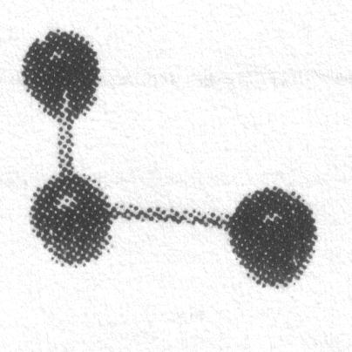

•

o

o

## Trigonal Planar

The shape around a central atom with **three bonding pairs** and **zero lone pairs** is trigonal planar. To minimize repulsion, the three electron pairs around the central atom are directed to the corners of an equilateral triangle and the shape around each carbon is described as being trigonal planar.

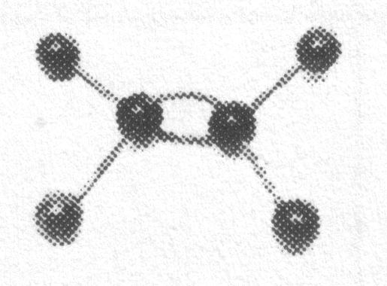

•

o

o

o

•

o

o

o

central atom

central atom

**Two important notes**:

1) When deciding on the “situation” around a central atom, **double and triple bonds count as one bonded pair**.

2) It is very important to understand that **VSEPR theory predicts the shape around a central atom only**. If there is more than one central atom in a molecule, each central atom can have a different shape around it. The molecule model picture to the right shows two central atoms bonded together by a double bond with two other atoms bonded to each central atom. VSEPR theory tells us that since each central atom has three bonded pairs (a double bond counts as one bonded pair) and no lone pairs, the shape around each central atom is trigonal planar

## Linear

The shape around atoms with **two bonding pairs** and **zero lone pairs** is linear. Examples include any carbon atom with a triple bond in a hydrocarbon.

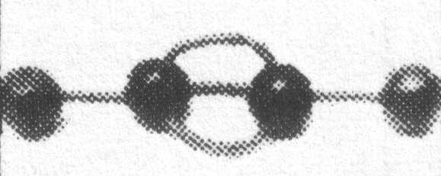

•

o

o

•

o

o

In addition, diatomic molecules (i.e. molecules like H2, O2, HCl, etc.) are necessarily linear since there are only two atoms involved.

o

o

_____________________________

From the descriptions of the shapes above, we can see that if we know the situation of the electron pairs surrounding a central atom we can predict the shape of the atoms around the central atom. The electron pairs repel each other and take up positions as far from one another as possible. One may use the following procedure to predict the shape of a molecule.

1. Draw the Lewis diagram or the structural diagram.

2. Count the number of lone pairs and bonding pairs around the central atom. Remember that, for the purposes of stereochemistry, single, double and triple bonds all count as one bonded pair.

3. Use the following to find the shape:

|  |  |  |  |
| --- | --- | --- | --- |
| **situation around central atom** | | **shape name** | **diagram** |
| **# LP**  •  o  o  o  o | **# BP** |  |  |
| 0 | 4 | tetrahedral |  |
| 1  •  o  o  o | 3 | trigonal pyramidal |  |
| •  o  o  o  2  •  o  o | 2 | angular |  |
| 0 | 3 | trigonal planar |  |
| •  o  o  or  o  o  0 | 2 | linear |  |

Now that we understand the shape of a molecule we can start to understand how different electron distributions can lead to an important phenomenon called **polarity**. But before we can discuss this property in terms of stereochemistry, we must first discuss how different electron attracting abilities between atoms results in altered electron distributions.

# Electronegativity

In lessons 9 and 10 we learned about the sharing of electrons to form covalent bonds. However, experimental evidence indicates that covalently bonded atoms often exhibit unequal attractions for shared electrons. In other words, when two atoms form a bond the shared electrons will spend more time around one atom than the other. In fact, different atoms have different **electron attracting abilities**. The relative attraction that an atom has for shared electrons in a covalent bond is known as its **electronegativity**. A scale of electronegativities was developed by Linus Pauling for which he would win the Nobel prize in 1954. The scale is a number in which the most electronegative atom, fluorine, was assigned a value of 4.0.

Examination of the electronegativities of elements given in the periodic table indicates the following trends.

1. Electronegativities increase from left to right within a period.

2. Electronegativities decrease from top to bottom within a group.

3. Electronegativities of the non-metals are high while those of the metals are low. This observation is consistent with the fact that metals tend to lose electrons (low electron-attracting-ability) and non-metals gain electrons (high electron-attracting-ability).

Note that the only inert gas that has an electronegativity value is xenon. This reflects the fact that inert elements normally do not form bonds. However, some clever chemists came up with a way to artificially induce xenon and fluorine to form xenon hexafluoride. Further, electron attracting ability is always to be understood in the context of a bond or relationship with other atoms. To speak of the electronegativity of an individual atom does not make sense.

The electronegativity scale is based on experimental evidence and reflects the relative reactivity of metals and non-metals (i.e. the lowest electronegativity belongs to the most reactive metals, Cs and Fr, while the highest electronegativity belongs to the most reactive non-metal, F).

# Polar and non-polar covalent bonds

How does a difference in electronegativity effect a covalent bond? The shared electrons within a bond are more strongly attracted to the atom with the higher electron-attracting ability (i.e. higher electronegativity). When we compare the electronegativities for hydrogen chloride, for example,

H

Cl

2.2 3.2

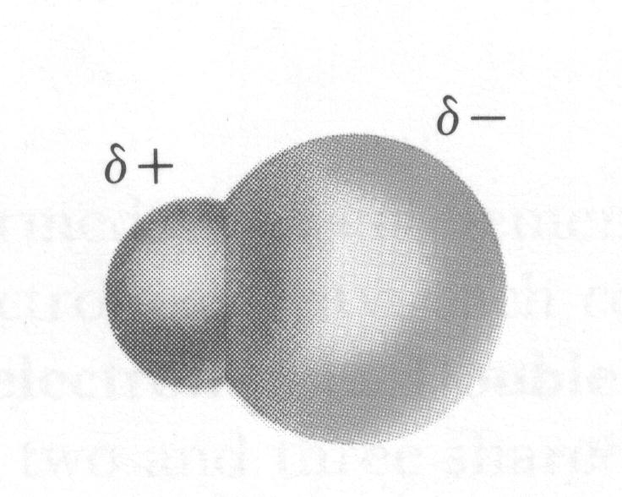

the shared electrons will spend more time around Cl since it has a greater electron attracting ability. In addition, since the bonding electrons (e−) are around the Cl atom the majority of the time, the Cl end of the molecule becomes partially negative (–) and the H end partially positive (+).

H

Cl

(+)

(–)

Covalent bonds in which the bonding electrons are unequally shared are called **polar covalent bonds**. Polar covalent bonds can be said to have a charge separation or a **bond dipole**. Such a bond dipole can be represented by an arrow with the arrowhead pointing towards the partially negative, more electronegative, atom. If, on the other hand, the atoms involved have the same electron attracting ability the result is a **non-polar covalent bond**.

# Assignment – part A

In the following diagrams draw an arrow to indicate the direction of the polar bond.

N

I

H

C

B

F

N

H

C

O

N

H

C

Cl

Br

Cl

S

C

I

I

F

F

H

H

Explain why cesium and francium are the most reactive metals.

Explain why fluorine is the most reactive non-metal.

# Polarity of molecules

So far we have learned about the stereochemistry of molecules and polar/non-polar covalent bonds. In order to determine the **polarity of a molecule**, the stereochemistry of the molecule must be known along with the presence of bond dipoles. The steps to be followed in determining the polarity of a molecule are:

1. Draw a Lewis or structural diagram of the molecule. When drawing a structural diagram remember that there may be lone pairs around the central atom(s) that determine the shape of the molecule.

2. Apply the VSEPR rules to draw or visualise the shape of the molecule. In general, if a molecule is **trigonal pyramidal** or **angular**, the result is a **polar molecule**. For the other shapes continue to the next step.

3. Use electronegativities to determine bond dipoles and draw these on the shape/structural diagram.

4. Imagine the bond dipole arrows as “force” vectors. If bond dipoles cancel or are symmetrical around the central atoms, the molecule is non-polar; if bond dipoles do not cancel, the molecule is polar. In every case, bond polarity is determined by addition of the bond dipoles arrows in concert with the directions they point.

The table below summarises the situations that give rise to molecular polarity or non-polarity when the atoms bonded to the central atom are identical. If non-identical atoms are bonded to the central atom, the bond dipoles may not cancel. For example, CH4 is non-polar, but CH3Cl is polar because the C–Cl bond dipole is not cancelled by the C–H bond dipoles.

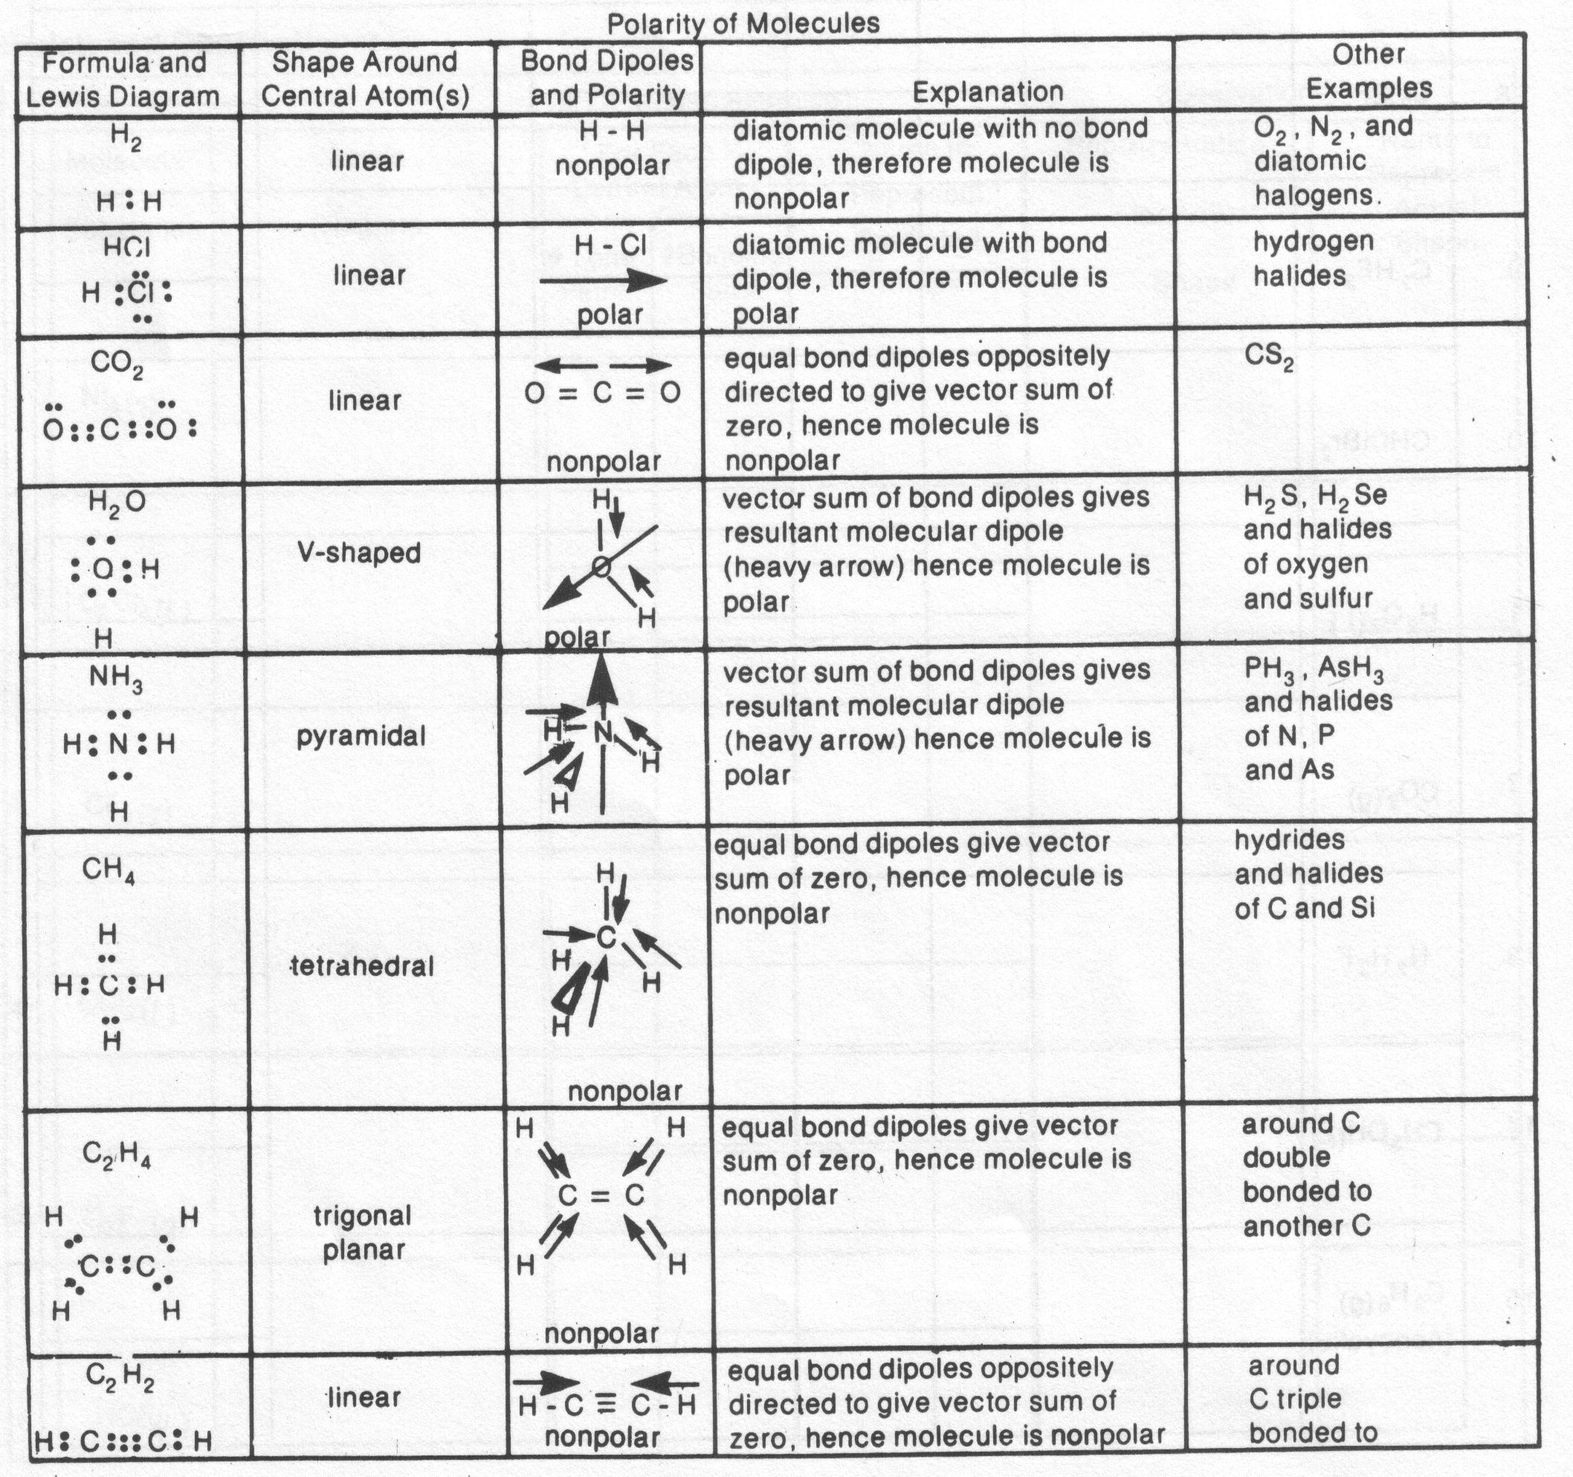

**Note**: It is very important that you, the student, do not confuse a **polar bond** with a **polar molecule**. A polar bond is the result of unequal sharing of electrons between two atoms within a molecule. A polar molecule is a molecule that has an overall polarity due to the shape of the molecule and/or the presence of bond dipoles within the molecule.

# Assignment – part B

For each of the following molecules:

a. draw the Lewis or structural diagram

b. determine the shape around the central atom(s)

c. draw arrows to represent bond dipoles

d. determine whether the molecule is polar or not

|  |  |  |  |  |
| --- | --- | --- | --- | --- |
| **Molecular**  **Substance** | **Lewis or structural diagram** | **Shape Around Central Atom(s)** | **Shape Diagram & Bond Dipoles** | **Polarity of molecule** |
| H  H  O  H2O | O  H  H | angular |  | polar |
| HF |  |  |  |  |
| NH3 |  |  |  |  |
| NH4+ |  |  |  |  |
| N2 |  |  |  |  |
| HBr |  |  |  |  |
| OCl2 |  |  |  |  |
| C2H2 |  |  |  |  |
| SiCl4 |  |  |  |  |

|  |  |  |  |  |
| --- | --- | --- | --- | --- |
| **Molecular**  **Substance** | **Lewis or structural diagram** | **Shape Around Central Atom(s)** | **Shape Diagram & Bond Dipoles** | **Polarity of molecule** |
| CO2 |  |  |  |  |
| CHI3 |  |  |  |  |
| C2H3Cl |  |  |  |  |
| CH4 |  |  |  |  |
| C2H6 |  |  |  |  |
| C2H4 |  |  |  |  |
| CH3OH |  |  |  |  |
| O2 |  |  |  |  |

|  |  |  |  |  |
| --- | --- | --- | --- | --- |
| **Molecular**  **Substance** | **Lewis or structural diagram** | **Shape Around Central Atom(s)** | **Shape Diagram & Bond Dipoles** | **Polarity of molecule** |
| O3 |  |  |  |  |
| H2O2 |  |  |  |  |
| C2H5OH |  |  |  |  |